Installation Instructions for Vehicle to Home (V2H) Excel + Python software that optimizes dispatch of backup generators to run home appliances

|  |  |
| --- | --- |
| Contact: | Carey King ([careyking@energy.utexas.edu](mailto:careyking@energy.utexas.edu)) |
|  | Dave Tuttle ([dptuttle@energy.utexas.edu](mailto:dptuttle@energy.utexas.edu)) |
|  | Lea Daniel ([leadaniel@utexas.edu](mailto:leadaniel@utexas.edu)) |

Contents

**Instructions for installing software for V2H tool** 2

Step 1: Install Python 2

Step 2: Enable macros in Microsoft Excel Macros in Excel are needed so that VBA in Excel can call the Python script that runs the optimization. 2

Step 3: Install a code editor to edit Python code 3

Step 4: Install the necessary Python packages 3

Step 5: Install the xlwings add-in and link to Excel 5

Step 6: Install Gurobi Optimizer 6

**Instructions for running the tool** 7

Step 1: Download Python code and Excel file 7

Step 2: Run the tool with given inputs 7

Step 2a: If Excel cannot find Python when trying to run tool 7

Step 2b: If Excel cannot find the “xlwings” add-in, due to accessing an incorrect folder 9

Step 3: Change inputs and run the tool 9

# **Instructions for installing software for V2H tool**

## Step 1: Install Python

Python 3: <https://www.python.org/downloads/>

I use version 3.8.13.

When installing Python 3.8, check the box for “Add Python 3.8 to PATH”

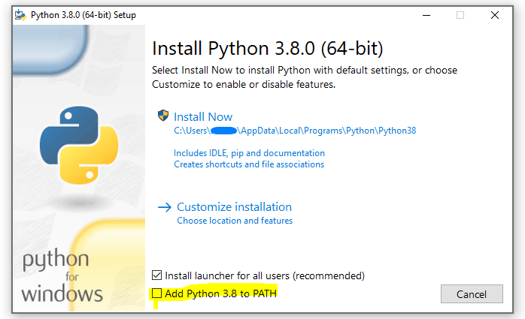

## Step 2: Enable macros in Microsoft Excel Macros in Excel are needed so that VBA in Excel can call the Python script that runs the optimization.

Make sure the “Developer” tab is in your ribbon so you can access VBA macros.

* Click “File” > “Options” > “Customize Ribbon” > Check the “Developer” box under “Main Tabs”

The “Run Scenario” button has a macro assigned to it. Select “Enable VBA Macros” to enable macros so that VBA can call the Python script.

* Click “File” > “Options” > “Trust Center” > “Trust Center Settings…” > “Macro Settings” > “Enable VBA macros”

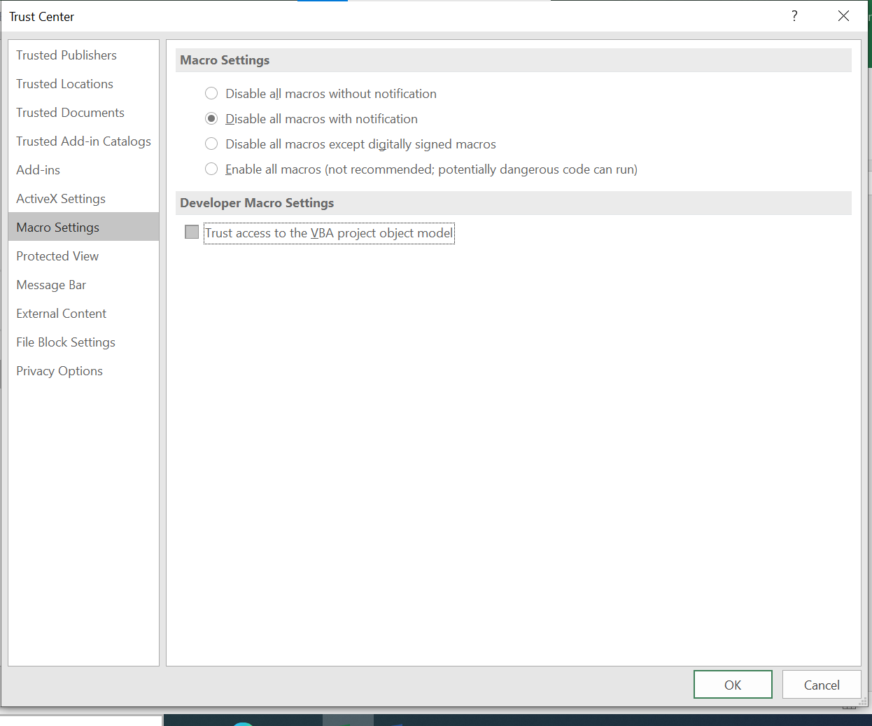

## Step 3: Install a code editor to edit Python code

I use VS Code, but any code editor can be used.

* VS Code: <https://code.visualstudio.com/>

Within VS Code, I use bash as my default command shell.

* Git BASH: <https://gitforwindows.org/>
  + Windows 10 already comes with a BASH editor

## Step 4: Install the necessary Python packages

You can install packages through the terminal (command prompt) within your code editor. A package manager may make it easier to keep track of packages. I use the miniconda package manager: <https://docs.conda.io/en/latest/miniconda.html>.

To install packages within your Python editor, you might have to enable miniconda within VS Code (or your Python editor) to enable easy installation of the Python packages.

**Installing necessary Python packages:**

Python packages that need to be installed since they are used in the code:

* pandas; version 1.4.2,
  + See installation instructions (command line codes): <https://pandas.pydata.org/docs/getting_started/install.html>
  + pandas is a Python library used for data analysis and manipulation.
* NumPy; version 1.20.3,
  + See installation instructions (command line codes): <https://numpy.org/install/>
  + NumPy is a Python library used for working with arrays.
* xlwings; version 0.27.6,
  + See installation instructions (command line codes): <https://docs.xlwings.org/en/stable/installation.html>
  + xlwings is a Python library that makes it easy to call Python from Excel and vice versa.
* pyomo; version 6.4.0
  + See installation instructions (command line codes): <https://pyomo.readthedocs.io/en/stable/installation.html> or <https://github.com/Pyomo/pyomo>
  + Pyomo is a Python-based, open-source optimization modeling language with a diverse set of optimization capabilities.
  + Command to install using miniconda: conda install -c conda-forge pyomo
* glpk; version 5.0 (GLPK is an open-source solver designed to solve linear programming, mixed-integer, and other related problems.)
  + See installation instructions (command line codes) using conda: <https://anaconda.org/conda-forge/glpk>
  + See installation instructions (command line codes) using pip/PyPI: <https://pypi.org/project/glpk/>

**(Alternative) Package Installation process outside of Python Editor** Open the Anaconda Powershell Prompt installed via miniconda.

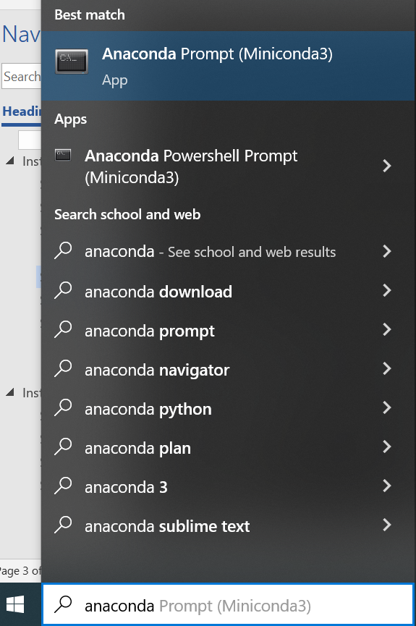

Install all the packages mentioned earlier using the following command:

conda install packagename

Note that the command to install package “pyomo” seems to be different:

(if installing using miniconda): conda install -c conda-forge pyomo

## Step 5: Install the xlwings add-in and link to Excel

xlwings is a package which allows for interaction between Excel and Python.

Install the xlwings add-in (xlwings.xlam) from a command line or download directly from GitHub.

* Version 0.27.6
* Command line: <https://docs.xlwings.org/en/0.16.0/addin.html>
  + To install the add-in, it’s easiest to type the following using the command line client: “xlwings addin install”
    - Built-in command line interpreters:
      * Command Prompt (cmd) on Windows
      * Terminal on Mac
    - I typed it into the VS Code terminal
* From GitHub: <https://github.com/xlwings/xlwings/releases>

You must link xlwings to Excel. To link xlwings to Excel, click “Developer” tab > “View Code” > “Tools” > “Reference” > check “xlwings addin” box

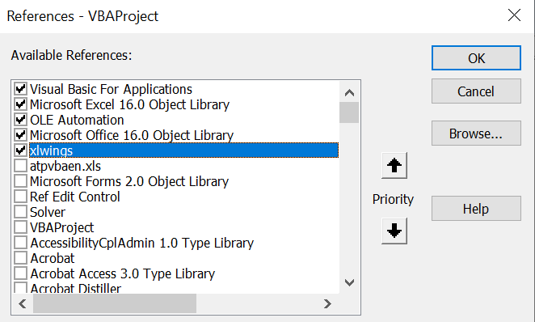

## Step 6: Install Gurobi Optimizer

Gurobi Optimizer is a commercial optimization solver for linear programming (LP), quadratic programming (QP), quadratically constrained programming (QCP), mixed-integer linear and quadratic programming (MIQP), and mixed-integer quadratically constrained programming (MIQCP). It is the preferred optimization solver option because it operates much more quickly (in seconds) for the most complicated problems within the tool, whereas the “glpk” optimization solver can take 10s of minutes for the same problem. We at UT Austin (as academics) can use the Gurobi solver for free. A private company must purchase the Gurobi Commercial version to use this tool we have developed. Gurobi does allow a company to try a free, full-featured, commercial evaluation license for 30 days. Download link: https://www.gurobi.com/downloads/request-an-evaluation-license/

Select “Account Type” as “Commercial”



# **Instructions for running the tool**

## Step 1: Download Python code and Excel file

Make sure the Python and Excel files are in the same folder.

* If using Gurobi solver
  + In the Python code, ensure that the following lines are not commented out:
    - opt = SolverFactory('gurobi')
    - opt.options['TimeLimit'] = 2
    - opt.options['OptimalityTol'] = 0.01
  + Comment out the following lines (as follows):
    - # opt = SolverFactory('glpk')
    - # opt.options['tmlim'] = 2
    - # opt.options['mipgap'] = 0.01
* If using GLPK solver
  + In the Python code, ensure that the following lines are not commented out:
    - # opt = SolverFactory('gurobi')
    - # opt.options['TimeLimit'] = 2
    - # opt.options['OptimalityTol'] = 0.01
  + Comment out the following lines (as follows):
    - opt = SolverFactory('glpk')
    - opt.options['tmlim'] = 2
    - opt.options['mipgap'] = 0.01
    - NOTE: The “glpk” solver is not as proficient as the “gurobi” solver, and might take hours (of real-world time) to solve an optimization across one day of backup generation (in the code). If using the “glpk” solver, we recommend you try to solve a very “small” problem of only 1 hour.

## Step 2: Run the tool with given inputs

Open the Excel file. Click the “Run Scenario” (At the bottom of the “User Interface” tab) button with the given default inputs just as they are in the downloaded file.

## Step 2a: If Excel cannot find Python when trying to run tool

You might receive the following possible error when clicking button to run the tool: Python was not found; run without arguments to install from the Microsoft Store, or disable this shortcut from Settings > Manage App Execution Aliases.

This URL has information to help alleviate this problem, and we describe the process below: <https://stackoverflow.com/questions/65348890/python-was-not-found-run-without-arguments-to-install-from-the-microsoft-store>

Open a Command Window and type “environment” or “environment variables” and you should be prompted to “edit the environment variables” (or similar):

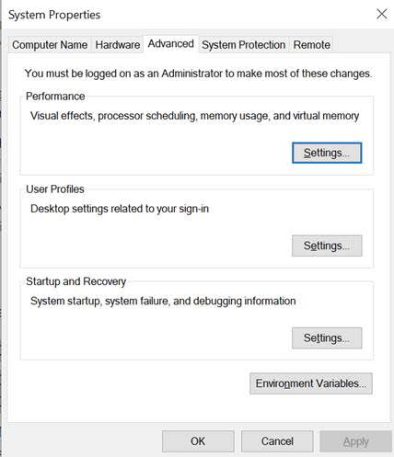

Then click “Environment Variables”:

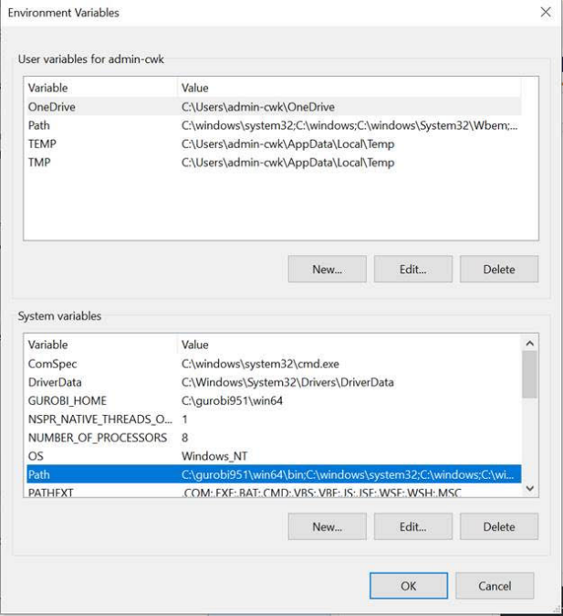

Then, in “System variables” (not “User variables”) click on “Path” and then “Edit” and add the appropriate file paths as mentioned/copied above.  For me (for example) these are:

C:\Users\cwk\AppData\Local\Programs\Python\Python310\Scripts

C:\Users\cwk\AppData\Local\Programs\Python\Python310\

As so:

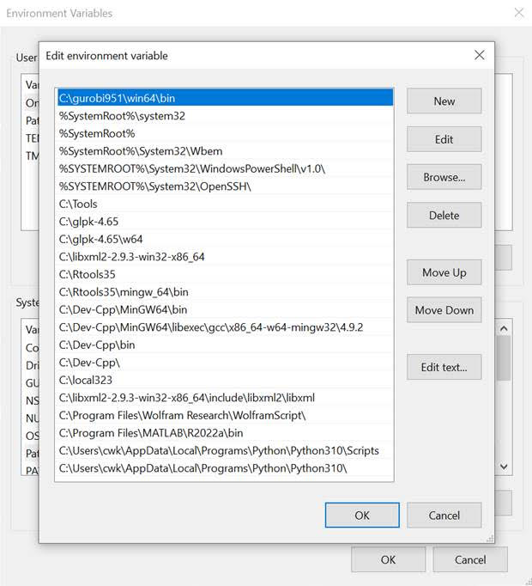

## Step 2b: If Excel cannot find the “xlwings” add-in, due to accessing an incorrect folder

When downloading the tool as the Excel file, this Excel file was (likely) first configured to run on another particular computer in which the “xlwings.xlam” file was located on that computer. You might receive an error (in Excel, after pushing the “RUN SCENARIO” button) such as:

**“Compile Error: Can’t find project or library”**

Thus, when running on your computer, Excel perhaps does not know the location of “xlwings.xlam”. To correct this problem,

1. In Excel go to: Developer (menu) 🡪 Controls: “View code” 🡪 Tools 🡪 References
2. Select “xlwings” from the list and (which might say “disconnected”), then the “Browse” button, and navigate to the folder in which you have stored the macro “xlwings.xlam”, and select “xlwings.xlam” in that folder.
3. If “xlwings” is not on the list of “References”, then use the “Browse” button, and navigate to the folder in which you have the macro “xlwings.xlam”, and select “xlwings.xlam” in that folder.

## Step 3: Change inputs and run the tool

Change weather condition, home size, backup sources, home load, and/or simulation run time inputs, then click the “Run Scenario” button.